Q 1

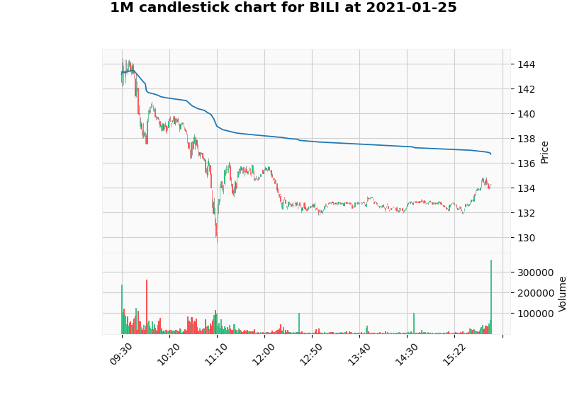

Q 2

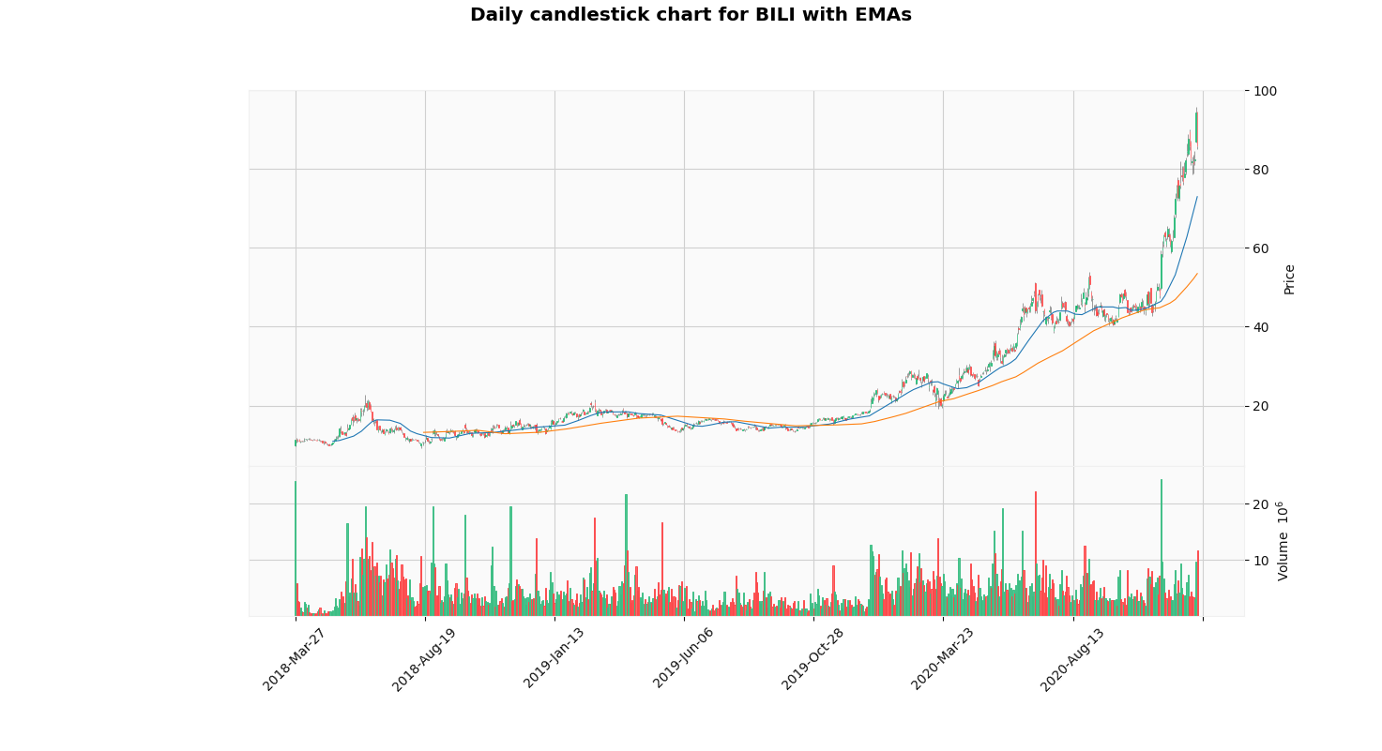

Q 3

1)

Data.head()

Unnamed: 0 c h ... v ts daily_return

0 0 11.24 11.26 ... 23929559 2018-03-27 20:00:00 NaN

1 1 11.00 11.80 ... 5863898 2018-03-28 20:00:00 -0.021584

2 2 11.00 11.50 ... 2771042 2018-04-01 20:00:00 0.000000

3 3 10.91 11.50 ... 2509609 2018-04-02 20:00:00 -0.008215

4 4 10.97 11.08 ... 1498443 2018-04-03 20:00:00 0.005484

2)

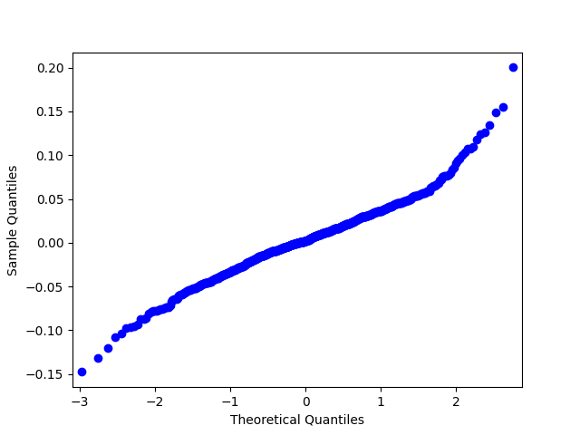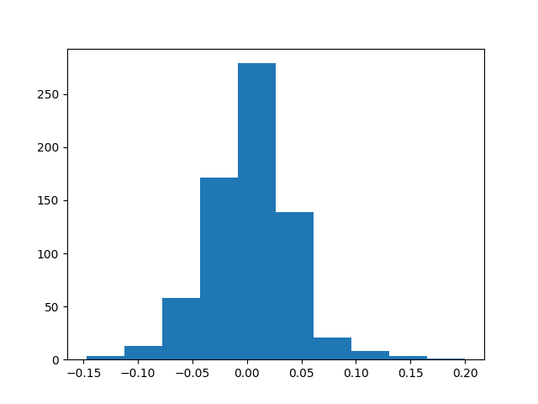

Statistics = nan, p = 1.000

Daily return of BILI looks Gaussian distribution (fail to reject H0).

Q 4

stocks = ['CRM', 'NFLX', 'AMD', 'HD', 'ABBV', 'CCL', 'T', 'DPZ', 'LB', 'XOM']

1)

time CRM NFLX ... DPZ LB XOM

0 2020-06-01 20:00:00 NaN NaN ... NaN NaN NaN

1 2020-06-02 20:00:00 0.004353 -0.012576 ... 0.013626 0.086068 0.039985

2 2020-06-03 20:00:00 -0.020495 -0.018271 ... -0.019045 -0.025444 -0.002847

3 2020-06-04 20:00:00 0.014132 0.012639 ... -0.016781 0.045450 0.077941

4 2020-06-07 20:00:00 0.015239 -0.000262 ... -0.001569 0.033170 0.030794

.. ... ... ... ... ... ... ...

144 2020-12-23 19:00:00 -0.007281 -0.000992 ... -0.017540 -0.005886 -0.004078

145 2020-12-27 19:00:00 -0.005062 0.009970 ... 0.008658 -0.003600 0.003360

146 2020-12-28 19:00:00 -0.009752 0.022382 ... -0.040335 -0.032198 -0.011324

147 2020-12-29 19:00:00 -0.000270 -0.011900 ... 0.000676 0.011637 0.007964

148 2020-12-30 19:00:00 0.000584 0.030303 ... -0.003021 -0.022335 -0.009177

2)

PCA component

[[ 0.01542019 -0.07820435 0.01454874 0.02212515 0.05667941 0.88830143

0.12658018 -0.03762737 0.29026947 0.31457655]

[ 0.37351968 0.36435338 0.51021226 0.17114825 0.06543016 -0.1891284

0.02016899 0.15480877 0.61128599 0.00525636]

[-0.49173869 -0.37116409 -0.27207564 -0.04188987 -0.03364102 -0.25532887

0.01588927 -0.02402316 0.69044097 0.02806267]

[ 0.51624308 0.23553539 -0.78679689 0.053945 0.03715342 -0.08611226

0.09305374 0.00273363 0.15029551 0.12651418]

[-0.2480166 0.16682424 0.06735908 0.18956883 0.35696104 -0.26287697

0.29642901 -0.09449495 -0.16894137 0.74048479]

[-0.51676651 0.70768818 -0.16808442 0.00936975 -0.19573301 0.14381216

0.02263921 0.35447205 0.00772009 -0.13628546]

[ 0.01338282 0.25728883 0.08061341 -0.39360939 -0.54587123 -0.06306324

-0.13535763 -0.60877717 0.07658029 0.27467844]

[-0.13596274 0.26193325 -0.04389753 0.02043684 0.57874711 0.08287835

0.01116633 -0.62066175 0.08199601 -0.42032651]

[ 0.04627945 0.05160158 0.0187674 -0.83386891 0.41568457 -0.02152841

-0.16425294 0.28909734 0.03879417 0.11911125]

[ 0.0506438 -0.04205722 0.06949771 -0.28079603 -0.13617771 -0.03804431

0.91697934 -0.00679741 -0.00905255 -0.22587397]]

PCA explained variance ratio

[0.45538919 0.22290102 0.1119501 0.07076524 0.0444276 0.03714638

0.02208135 0.01714359 0.01056832 0.00762721]

3)

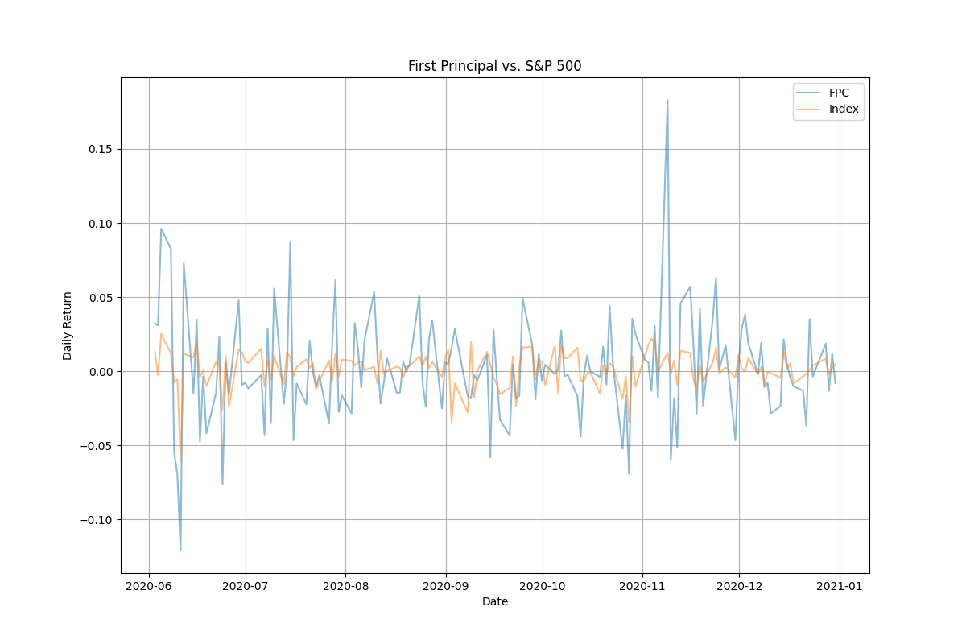

4) nan